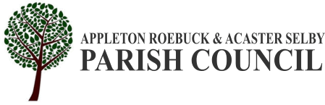

APPLETON ROEBUCK AND ACASTER SELBY PARISH COUNCIL
www.appletonroebuckandacasterselby-pc.gov.uk.
Clerk to the Council: Mr Jake Harrison, Parish Rooms, Daw Lane,
Appleton Roebuck, YO23 7BL
E-mail: clerk@appletonroebuckandacasterselby-pc.gov.uk

A Meeting of the Parish Council will be held in the Parish Room, Post Office Square, Appleton Roebuck on: Wednesday 3rd June 2026 At 7:30 PM
The Members of the Parish Council are hereby summoned to attend for the purpose of considering and resolving upon the business to be transacted at the meeting as set out below. The press and public are invited to attend. Please note that anyone wishing to record the meeting should make a prior request to the Clerk and comply with the Recording of meetings policy.
Jake Harrison - Clerk to the Council
Tuesday 26th May 2026
AGENDA
01 To receive apologies for absence.
02 To receive declarations of interest.
03 To confirm the minutes of the Parish Council meeting and the Annual Meeting of the Council held on Wednesday 6th May 2026 as a true and accurate record.
04 To consider matters arising from the above minutes.

05 FINANCE MATTERS:
1) To approve following payments:
a) Simply Cleaning £378
b) Moorland Garden Services £660
06 To receive updates on outstanding actions from previous meetings not covered elsewhere on the agenda.
07 PLANNING; to consider planning decision notification(s).
There were none.
08 PLANNING; to consider planning application consultation notification(s).
a) ZG2026/0404/HPA
PROPOSAL: Erection of single storey extension and new front porch
LOCATION: 6 West End Avenue, Appleton Roebuck, YO23 7DE
09 To consider a recommendation from Ashton’s regarding an increase to the Parish Cottage rent – JR
10 To consider an update on traffic safety in the Parish – MS
11 To consider village aesthetics – TC
12 To consider Burial Ground Maintenance – TC
13 To consider an update on the proposed new play area in Appleton Roebuck, and to determine whether the project should continue progressing in its current form and location- MS
14 To consider the reopening of North Yorkshire Council’s Call for Sites consultation and any potential implications for Appleton Roebuck – JR
15 To consider correspondence including late items.
16 To receive and discuss parishioners’ comments.
17 Date of next meeting: Wednesday 1st July 2026

