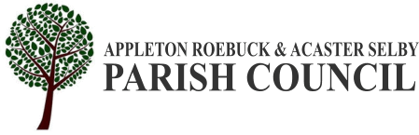

APPLETON ROEBUCK AND ACASTER SELBY PARISH COUNCIL
www.appletonroebuckandacasterselby-pc.gov.uk.
Clerk to the Council: Mr Jake Harrison, Parish Rooms, Daw Lane,
Appleton Roebuck, YO23 7BL
E-mail: clerk@appletonroebuckandacasterselby-pc.gov.uk

A Meeting of the Parish Council will be held in the Parish Room, Post Office Square, Appleton Roebuck on:
Wednesday 5th November 2025 At 7:30 PM
The Members of the Parish Council are hereby summoned to attend for the purpose of considering and resolving upon the business to be transacted at the meeting as set out below. The press and public are invited to attend. Please note that anyone wishing to record the meeting should make a prior request to the Clerk and comply with the Recording of meetings policy.
Jake Harrison - Clerk to the Council
Friday 31st October 2025
AGENDA
01 To receive apologies for absence.
02 To receive declarations of interest.
03 To confirm the minutes of the Parish Council meeting held on Wednesday 1st October 2025 as a true and accurate record.
04 To consider matters arising from the above minutes.

05 FINANCE MATTERS:
1) To approve following payments:
a) Moorland Garden Services £660
b) Vestar £49
c) Simply Cleaning £420
2) To consider the 2nd Quarter Banking Resolution
3) To be advised that the precept will be set at the December meeting.
4) To consider the receiving of a £60.36 CIL payment from Planning ref: 2022/0106/FUL – Roebuck Barracks, Green Lane, Appleton Roebuck
06 To receive updates on outstanding actions from previous meetings not covered elsewhere on the agenda.
07 PLANNING; to consider planning decision notification(s).
There are none.
08 PLANNING; to consider planning application consultation notification(s).
a) ZG2025/0951/FUL
PROPOSAL: Sub divide existing dwelling into two properties, with minor alterations and extensions
LOCATION: The Greenings, Bond Lane, Appleton Roebuck
09 To set a meeting date regarding correspondence from the Pre-School Group.
10 To consider correspondence from a Parishioner regarding dangerous driving in Appleton Roebuck.
11 To consider an update on the administration of the Burial Ground.
12 To consider correspondence including late items.
13 To receive and discuss parishioners’ comments.
14 Date of next meeting:

Wednesday 5th November 2025.

